

DA DIS Heavy Access Database Approach - 16.2 Onwards

User Guide

© 2017 DXC. Falls Church, Virginia. All rights reserved. No part of this publication may be reproduced by any means without written permission from DXC. Printed in U.S.A. All questions regarding this documentation should be routed through customer assistance, Blythewood, SC, 800-420-6007 or email [pcssupport@dxc.com](mailto:pcssupport@dxc.com).

**Table of Contents**

|  |  |
| --- | --- |
| 1. | Introduction |
| 2. | DA-DIS Option Set Page |
| 3. | Steps to be followed for this approach |
| 4. | Validation Errors that might appear on UI |
| 5. | Points to remember |

1. **Introduction**

Data Analytics - Data Import System (DIS) heavy file approach is implemented if the size of import file is very large **(above 100 MB)**. In this case instead of using import file (access database (*.mdb/ .accdb*)),source data needs to be populated directly into the *ACCESS STAGING DATABASE* with the unique value in newly added **‘BATCH_ID’** field aswell.

**\*Note:** Currently, DIS functionality of uploading import file directly from UI has file size

limitation (max of 100MB) hence this new functionality is introduced.

This enhancement is implemented in RMA16.2.The key features of this enhancement are as follows:

* Large amount of data to be directly inserted in Access Staging Database
* New field **‘BATCH_ID’** to be populated in Access Staging Database tables.
* The above **‘BATCH_ID’**value will be used on UI while creating the Optionset/Scheduling DIS job via DIS UI page.
* Error will be thrown if the correct **‘BATCH_ID’** is not entered on UI as given in Access Staging Database tables.

## DA DIS Optionset Page

Initially, DIS Optionset window had the option “***Select Access Database to import from***” to browse import file (mdb/accdb), now one more option for heavy file (>100MB) is introduced on DIS UI i.e “***Select Heavy Access Database to Import From***“ which indicates if user has large amount of data then s/he has to populate the data directly into the Access Staging Database first before scheduling the DA DIS job.

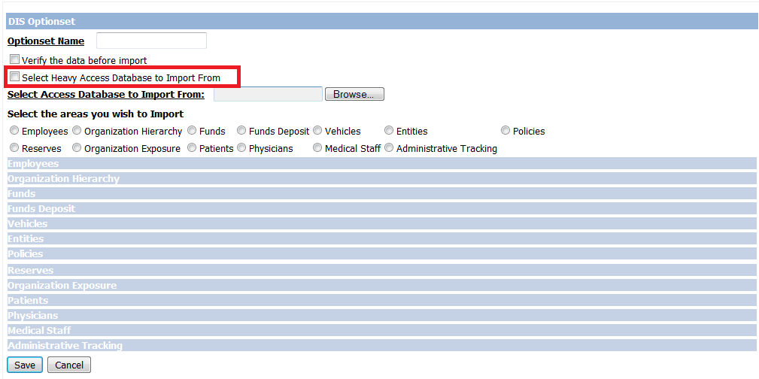

Figure 1: DA - DIS Optionsetwindow

When user selects checkbox “***Select Heavy Access Database to Import From***“ then the browse option will not be visible and a **‘BATCH_ID’** textbox will appear (*Figure 2*).

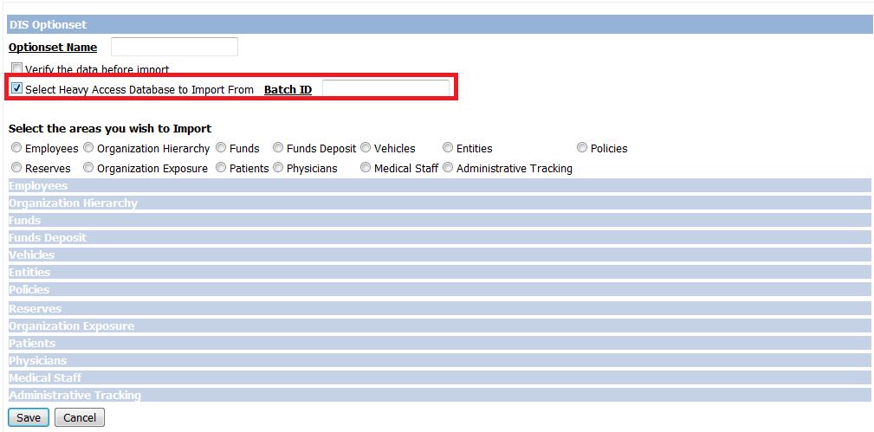

Figure 2: DA-DIS Optionsetwindow(Heavy file checkbox selected)

User needs to add a valid **‘BATCH_ID’** as present in Access Staging Database in this textbox otherwise validation errors will be thrown while scheduling the Job/Optionset.

## Steps to be followed for this approach

If user selects this checkbox (“***Select Heavy Access Database to Import From***“) then below approach needs to be followed:

**Step1-** Before scheduling the Optionset/Job from DIS UI, user needs to directly

populate/insert the data to Access Staging Database which is used by RMA(Refer to the”AccessStagingDataSource” node in connection string present in wcfservice for the name of access staging database).



Figure 3: Connection String

**Step 2-** All the tables of Access Staging Database is having a column **‘BATCH_ID’.** User needs to provide same value of **‘BATCH_ID’** in all the rows of all the

respective tables related to that module for which the job is to be executed. (Refer “Mapping Document”).

**Note : Only numeric value is to be given for ‘BATCH_ID’column.**

**Step 3-** Once user has added the data directly to the Access Staging Database tables with **‘BATCH_ID’** column value, then he can go to RMA-UI and schedule the Job/Optionset for DIS.

**Step 4-** While scheduling the job the **‘BATCH_ID’**to be provided on UI should be the same which is populated by the user in Access Staging Database tables in Step 1 and 2.

**Step 5-** Once the Step 4 is completed, **‘Optionset_Id’** column in Access Staging Database tables will get updatedfor all the records in the related tables of the module for which job was scheduled with a unique value.

## Validation Errors that might occur on UI

1. If **‘BATCH_ID’** entered on UI doesn’t exists in Access Staging Database tables

related to the module for which job is to be scheduled then the following error will be reported:

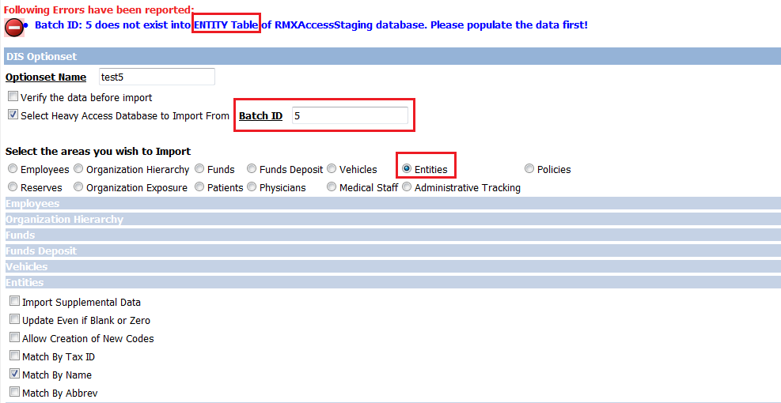

Figure 4: DA-DIS Optionset window

2. If user has mistakenly entered some other ‘**BATCH_ID’** (which he might have created/used for data of previous JOB’s) then following error will be reported.

**Note:** The below error is specific to ENTITY module of DIS only. It will get changed according to the import module for which user has created the Job.

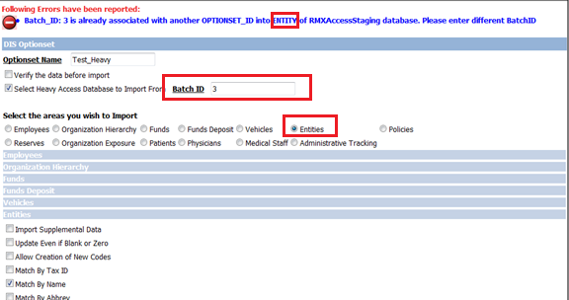

Figure 5: DA-DIS Optionset window

3. If the structure of any table is modified by the end user in the tables of Access Staging Database (i.e. mismatch in datatype or any column has been dropped mistakenly). The following error will be reported:

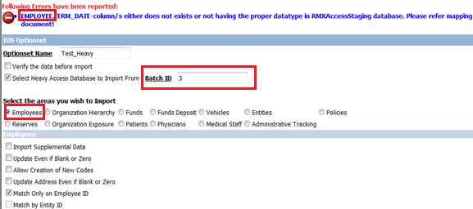

Figure 6: DA-DIS Optionset window

4. If the table is mistakenly dropped by the user for which the optionset/Job(module for which DA DIS job need to be scheduled) is to be created the following error will be reported:

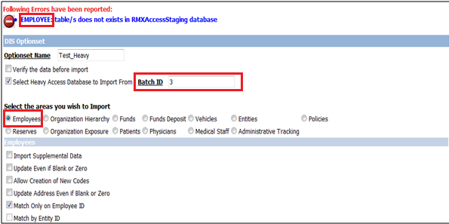

Figure 7: DA DIS Optionset window

## Points to remember

1. ‘**BATCH_ID’** is a unique numeric field.
2. If user has entered data in Access Staging Database tables for more than one job then make sure **‘BATCH_ID’** column contains unique value for all the rows corresponding to a particular job.
3. **‘BATCH_ID’** needs to be entered in all the tables that are required for executing that particular job.Example for running Employee import user has to enter the data and **‘BATCH_ID’** in EMPLOYEE and ENTITY table of Access Staging Database. Also if user wants to attach Violations and Dependents for Employee area then EMP_X_VIOALTION and EMP_X_DEPENDENT tables should also contain the data with same **‘BATCH_ID**’.
4. User’s need to remember **‘BATCH_ID’** for every job while scheduling the job/optionset from UI because Optionset_Id (a unique option set get created when DIS job is scheduled) column in tables of Access Staging Database will get updated in all the records corresponding to the **‘BATCH_ID’** that is provided by the user on UI. So if **‘BATCH_ID’** provided on UI exists in Access Staging tables but is for some other job whose Optionset/Job is yet to be created then it will update those records and unknowingly Job with wrong set of records will be executed.
5. In case the checkbox (“***Select Heavy Access Database to Import From***“) is selected, all tables in Access Staging Database for which job was scheduled will get cleared after execution ONLY if job status on UI is **“COMPLETED”**. If not using this approach then Access Staging tables will get cleared after every run of job.
6. If the user is trying to import **Supplemental Tables** through DIS then before scheduling the optionset “XML_TOOLKIT” must be executed so that supplemental structure gets created in the Access Staging Databasealong with a new **‘BATCH_ID’** column, otherwise error will be thrown on UI while scheduling the job.

**Note:** If job status after execution on UI is “Completed with Error” or “Failure to Launch” then user has two options.

1. Update the Optionset for all the rows to blank for which previous job was scheduled and then you can use the same data again for which the previous job could not be executed successfully.
2. Populate the data again and delete the existing data for which the job could not be executed in Access Staging Database tables with new value in ‘BATCH_ID’ and then schedule a new Job.